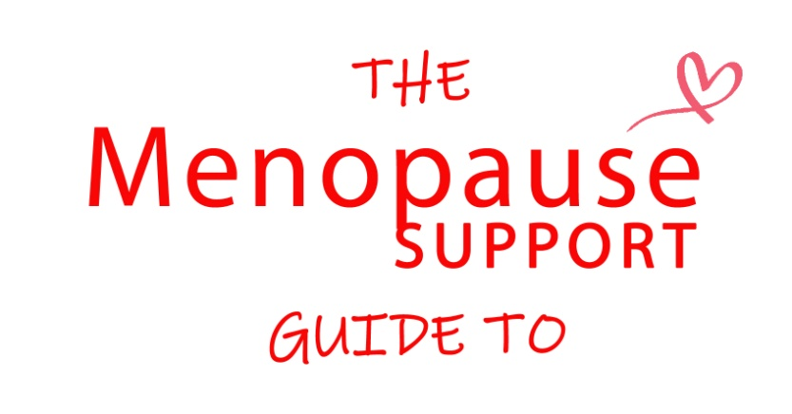
Understanding the Psychological Impact of Menopause
In April 2012 I hadn’t given menopause a second thought, twelve months later I had been completely consumed by it. At the time I had no idea about the mental and emotional symptoms of menopause, several years later I now counsel and support other women having learnt so much, both personally and professionally, about the menopause transition.
Menopause is of course a natural stage of life but one that nobody prepares us for as we still don’t really talk about it either at home or at work. For those women who experience an early menopause the shock can be even greater when your symptoms arrive, sometimes very suddenly, well before your early fifties.
Menopause is a very individual experience but even the 25% of women who do not immediately experience symptoms still speak of a shift happening in their lives. It’s important to note that many of those who think they have gone through menopause without symptoms are likely to develop urinary and vaginal symptoms related to oestrogen depletion as they age. So what exactly is responsible for these shifts, changes and transformations…..hormones!
Anyone who has experienced pre menstrual syndrome will be well aware of the emotional rollercoaster that fluctuating hormones can cause during the reproductive years but many women are simply not prepared for the variety and intensity of those symptoms which affect some women at menopause.
Fluctuating Progesterone, Oestrogen and Testosterone levels can be responsible for anxiety, panic, feeling tense or nervous, feeling unhappy or depressed, irritability, poor concentration and plummeting self esteem. The stress of not understanding what is happening can intensify all those feelings and the fear of admitting to any of them can make life feel very lonely indeed.
All too often the mental and emotional symptoms of menopause are incorrectly diagnosed as depression and medicated with anti depressants. Being labelled as depressed when you really don’t feel that you are can be frightening and very isolating, women often tell me how desperate they feel when they know they are not depressed but can’t make their doctor understand.
Emotional health can also be impacted by the physical symptoms of menopause, broken sleep, which is a common complaint, can wreak havoc with our energy and concentration levels and this only adds to the stress. Whilst hot flushes in public can be embarrassing for some it is often the more private symptoms of vaginal dryness and increased urinary symptoms that have an impact on self confidence and our most intimate relationships with partners.
Communication is vital in any relationship but it is particularly important during menopause. When women don’t understand what is happening to them they find it hard to talk about it, if we don’t understand what hope do our partners have? I have counselled so many couples very much in love who have drifted apart both physically and emotionally simply due to a lack of knowledge about the menopause.
The physical impact of menopause means of course that the reproductive stage of a woman’s life is drawing to a close. Regardless of whether a woman has chosen to have children has actively decided not to or has been unable to conceive this transition can present feelings of loss and grief as the choice of any possibility of bearing a child slip away.
In a recent BBC survey 48% of women said the menopause had a negative impact on their mental health. The survey found that 70% of women did not speak to their employers about the effects of their menopause symptoms on their work life. This can lead to additional stress as many women are fearful of being seen as less productive, many have told me that they use the last of their energy just to get through the day and then collapse with exhaustion when they get home.
So hormones are clearly responsible for a variety of psychological symptoms both directly and indirectly but the story doesn’t end there. Menopause is very much a psychological shift too, common themes that come up in therapy are the need to stop, reflect and restore. Many women speak about the desire to spend time alone, to work through anything that has held them back in the past and to move forward with a clean slate.
This is a time when the needs and expectations of others seem to matter a little less and self care becomes a priority. Many women now connect, for the first time, with the inner voice of authenticity so often drowned out by the cacophony of daily life and social expectation. Some decide to reconnect with former passions, whether professionally or as a hobby, others let their hair dye grow out, go make up free for the first time or take that gap year they have always promised themselves.
More significantly there is very often a shedding of existing habits and sometimes current connections. Many women find that menopause is when they really find their voice and can no longer tolerate relationships and situations that they have put up with in the past simply to keep the peace and make others happy at their own expense. With the right advice and support menopause presents an opportunity to clear the clutter of the past and move on to the best years of your life.
Diane Danzebrink (dianedanzebrink.com) is The Menopause Counsellor a Psychotherapist with professional nurse training in Menopause; she is a member of the British Menopause Society and the founder of menopausesupport.co.uk and the #MakeMenopauseMatter campaign.

